Small Molecule Fluorescent Probes and Their Nano-interfaces for Intrinsic Optical Imaging and
Improved Biomedical Functions

Dr. Bengang XING
Division of Chemistry and Biological Chemistry
School of Physical and Mathematical Sciences
Nanyang Technological University (新加坡南洋理工大学)

Email: Bengang@ntu.edu.sg
Weblink: http://www.ntu.edu.sg/home/bengang/

Biomedical specificity is normally mediated by precise and selective regulation of protein ad enzyme functions in response to intrinsic development programs and extrinsic signals. In order to fully understand the protein or enzyme functions and further elucidate their mechanisms in biomedicine, it is essential to apply a simple and reliable assay with high sensitivity and fidelity that can efficiently report the biological processes of interests at the single cell or molecular level. In general, small molecule fluorescent imaging technique is among the most powerful methods for in vitro and in vivo screening of protein or enzyme functions because of their high sensitivity, relative safety, and easily handling. By studying the chemical reactions of enzyme or proteins with the fluorescence conjugated small molecule substrates, and meanwhile in vitro and in vivo evaluating of their stability, cellular permeability and potential biomedical properties, the specific enzymes or proteins activities and related biological pathways can be non-invasively monitored in a highly effective manner. In our group, a series of simple and specific fluorescent/bioluminescent probes have been proposed to real-time visualize the special drug resistant enzyme functions. Moreover, the new approaches based on the integration of small molecule probes with unique nano-sized building block structures were also introduced to understand the mechanisms of therapeutic activity and to investigate the specific biological pathways in the drug resistant living species.
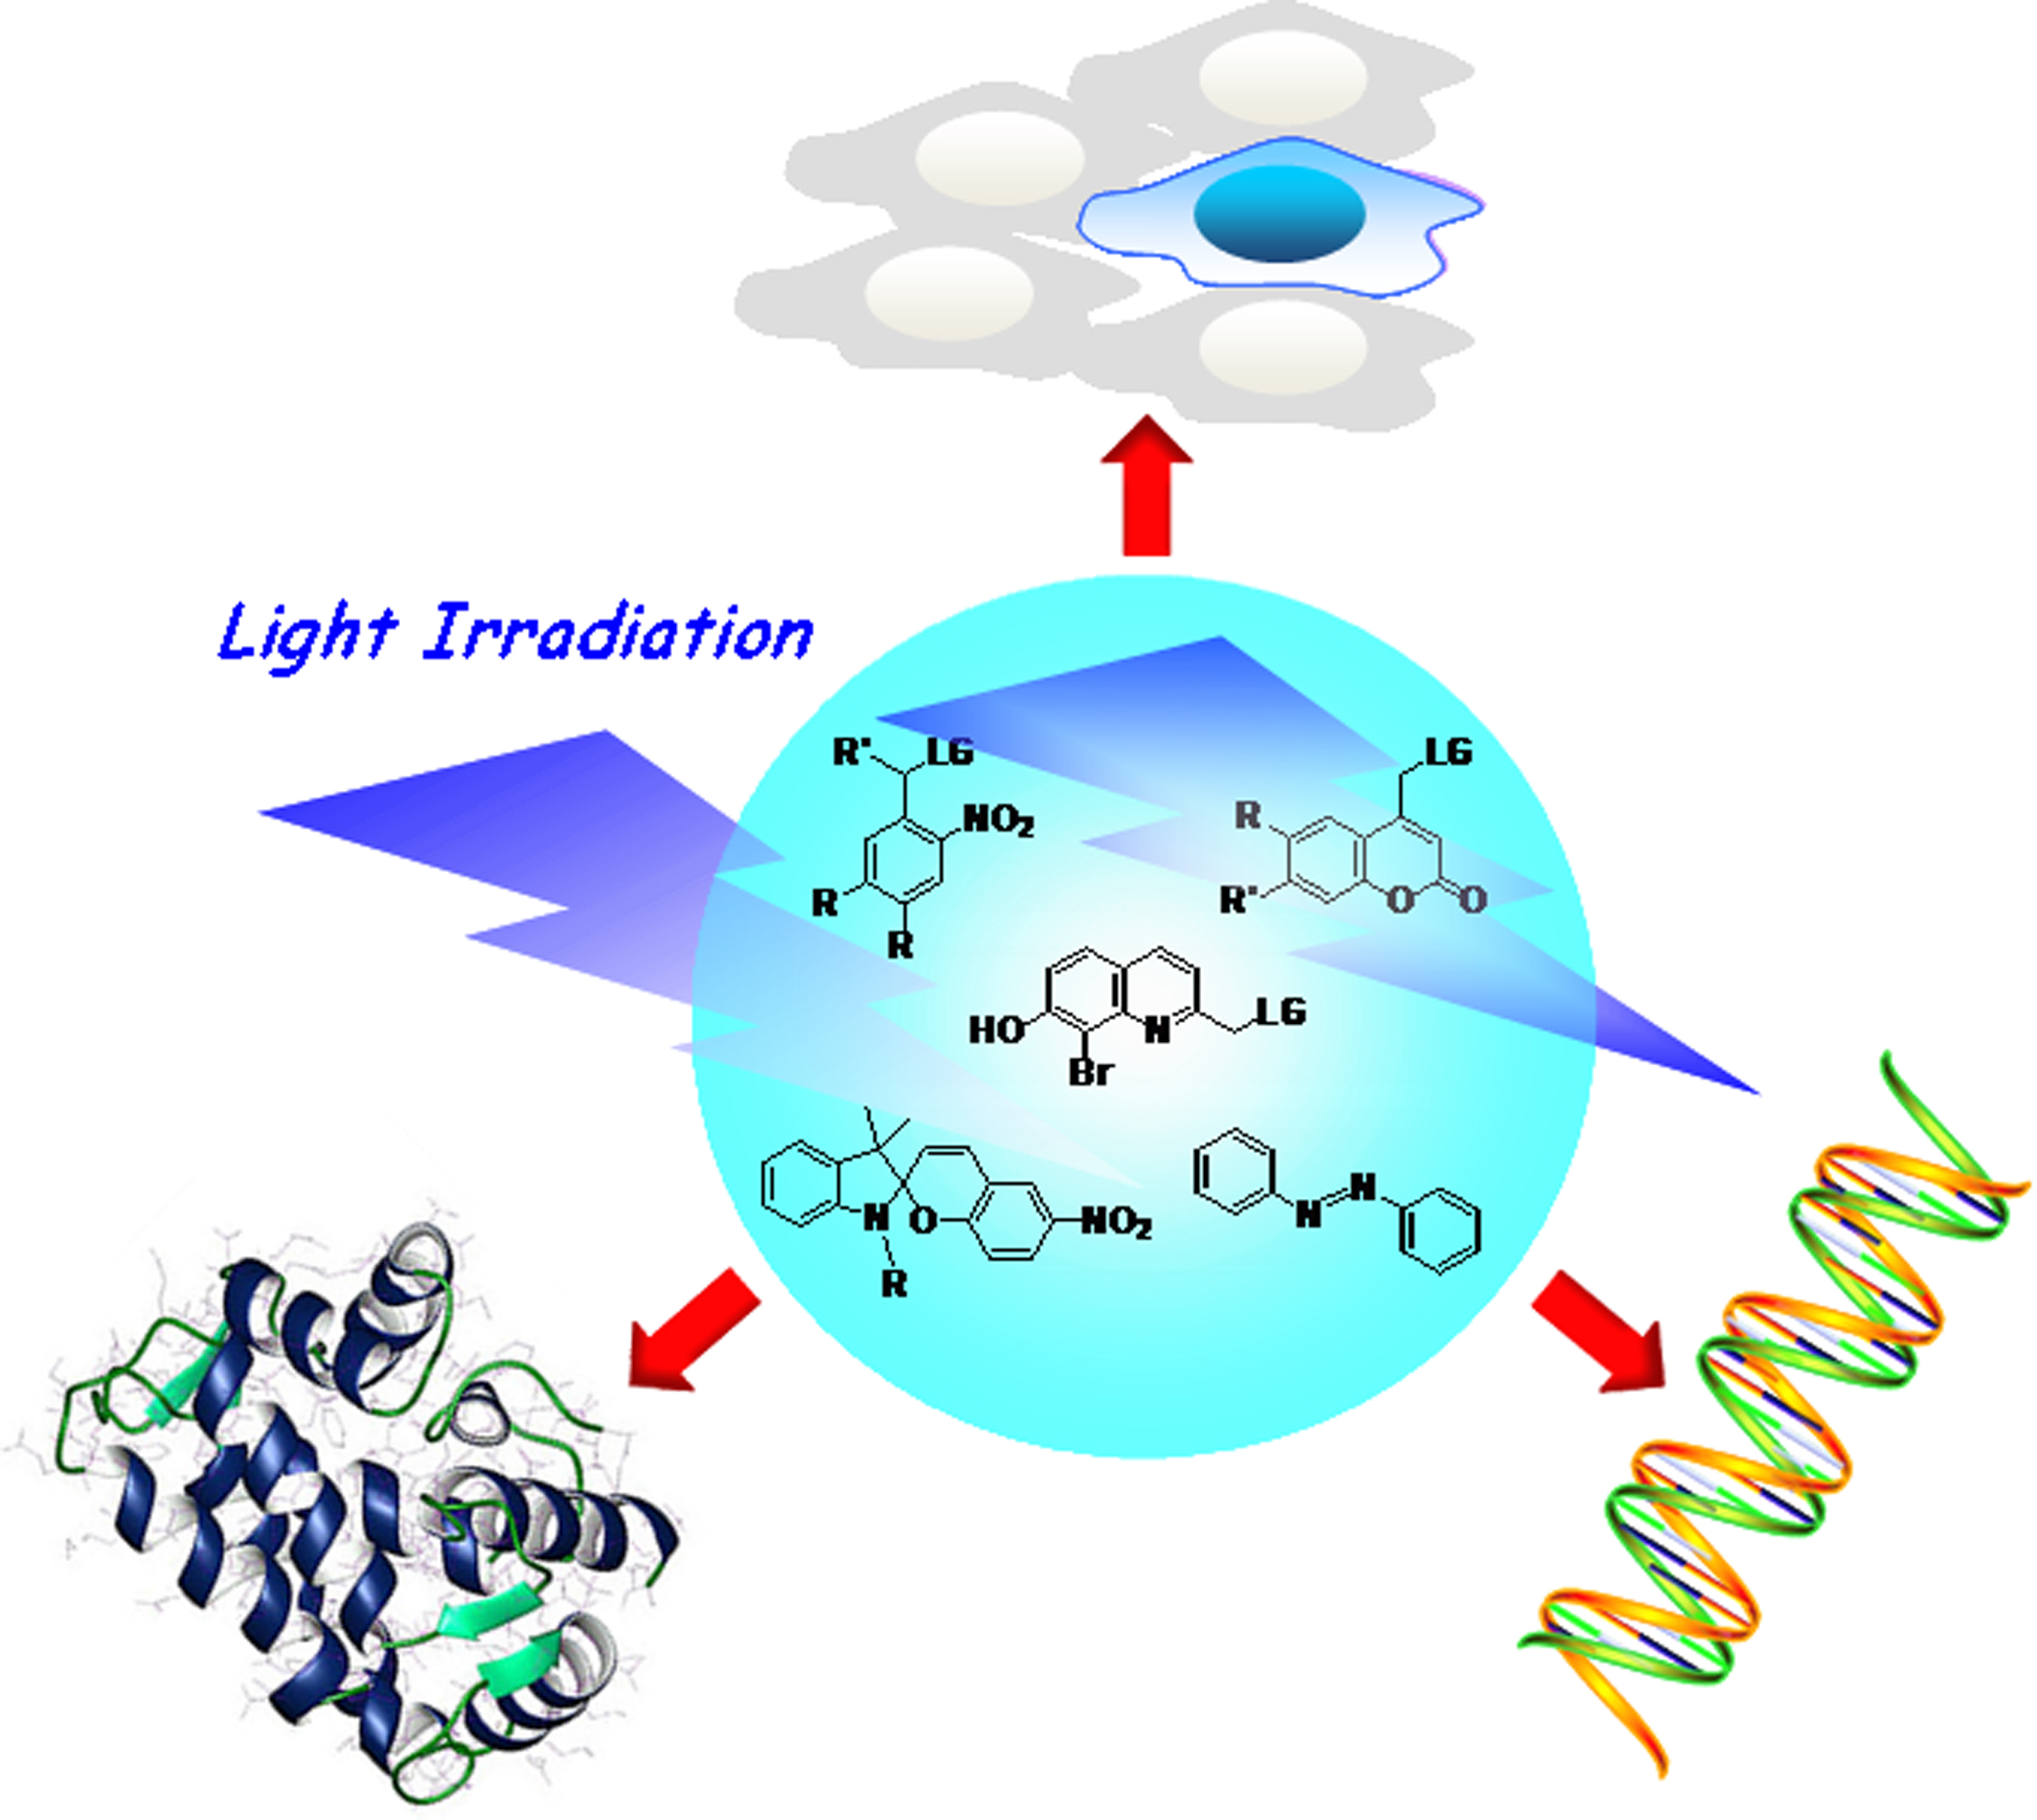

Acknowledgments, The authors gratefully acknowledge Tier 1(RG64/10), A*Star SERC and start-up grants in Nanyang Technological University, Singapore for financial supports.

